UNIT 2 DESCRIBING PEOPLE
PART ONE WARMING UP
Task 1: Look at the following picture. Supply the vocabulary to form the image.
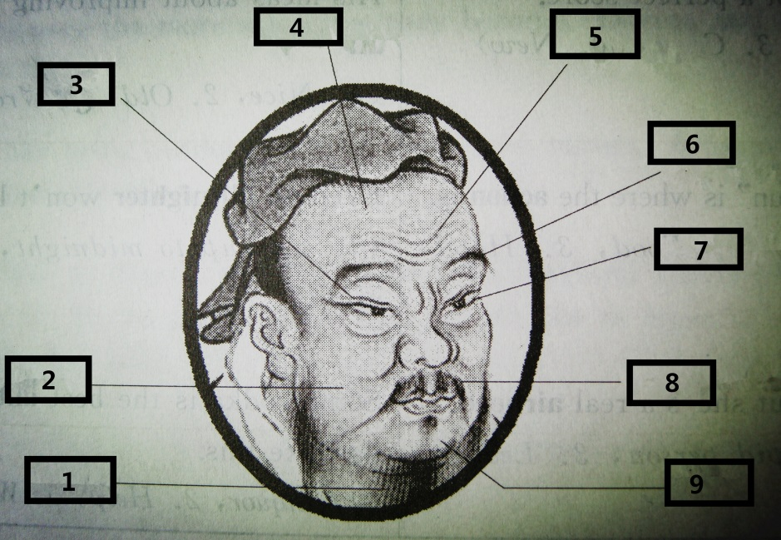

1）____beard_______
2）____cheek____
3）____eyelid____
4）____forehead___
5）____wrinkles____
6）____eyebrow____
7）____eyelashes___
8）____moustache__
9）____chin ____

PART TWO
Text 1
Pictures from my trip back home
Key
fair dark dark
heart-shaped thin bushy
wavy
cute curly adorable

Text 2
iGenius – How Steve Jobs changed the world *

Task 1: Watch the video named “iGenius – How Steve Jobs changed the world” and complete the facts of Steve Jobs.

Achievements:
- Changed people’s lives with products such as __the PC_______, _the iPod__, _the iPhone_, and _the iPad_.
- Called the iGenius for making complicated things _simple_ and _beautiful_.
Early years:
- Born in __1955__.
- Adopted by a working-class couple in California’s _Silicon Valley_.
- Went to Oregon in __1972__ and attended a college.
- Liked the music of the Beatles and Bob Dylan, took drugs and went to _India__.
- Returned to California in __1975_.
Apple I:
- Joint effort of Steve Jobs and Steve Wozniak.
- Had no _power supply_ or __casing_, just a beginning.
Apple Computer Inc:
- Formed with the help of an _investor_.
Apple II:
- A great improvement of Apple I.
- Faster, had _ text display _, color graphics and _ plastic casing_.
- The reinvention of _the mouse_ was a huge success.
- Good sales brought Apple Company to go public in __1980_ and made Steve Jobs worthy of $_200 million__ at the age of ___25__.

Task 2: Listen to the recording and take notes of the words used to describe Steve Jobs.

had a vision, demanding perfection, could rip into people, tough to work for, genius, difficult, tough, dictatorial, with a very clear sense of his instinct, abrasive, brash, thought he knew everything, “the guy”…

PART THREE SPEAKING
Task 1: Watch the music video “You belong with me” and fill in the blanks.

- humor
- short skirts
- easy
- high heels
- laugh
- dreams

PART FOUR LONG CONVERSATION BOX

Task 1: Listen and answer the questions you have just heard.

Key
8. D 9. B 10. B 11. C

Task 2: Listen and answer the questions you have just heard.

Key
C D C C

PART FIVE HOMEWORK
Task 1: Listen to the short biographies and complete the table below.

Name | Nationality | Birth | Death | Achievements
Albert Einstein  (physicist) | American | March 14, 1879 | 1955 | the 1921 Nobel Prize in Physics  the creator of the theory of relativity
Wolfgang A. Mozart  (composer) | Austrian | 1756 | 1791 | 41 41 symphonies, 27 piano concertos, 23 string quartets, 17 piano sonatas, 7 major operas, and numerous works for voice and other instruments
William Shakespeare  (playwright and poet) | English | 1564 | 1616 | His works include poetry, comedies and tragedies

