UNIT 2 DESCRIBING PEOPLE
PART ONE WARMING UP
Task 1: Look at the following picture. Supply the vocabulary to form the image.
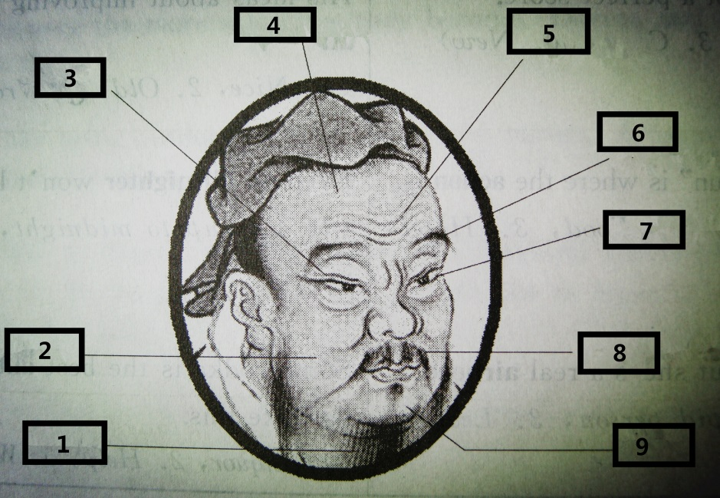

1）____beard_______
2）____cheek____
3）____eyelid____
4）____forehead___
5）____wrinkles____
6）____eyebrow____
7）____eyelashes___
8）____moustache__
9）____chin ____

PART TWO
Text 1
Pictures from my trip back home
Key
fair dark dark
heart-shaped thin bushy
wavy
cute curly adorable

Text 2
iGenius – How Steve Jobs changed the world *

Task 1: Watch the video named “iGenius – How Steve Jobs changed the world” and complete the facts of Steve Jobs.

Achievements:
- Changed people’s lives with products such as __the PC_______, _the iPod__, _the iPhone_, and _the iPad_.
- Called the iGenius for making complicated things _simple_ and _beautiful_.
Early years:
- Born in __1955__.
- Adopted by a working-class couple in California’s _Silicon Valley_.
- Went to Oregon in __1972__ and attended a college.
- Liked the music of the Beatles and Bob Dylan, took drugs and went to _India__.
- Returned to California in __1975_.
Apple I:
- Joint effort of Steve Jobs and Steve Wozniak.
- Had no _power supply_ or __casing_, just a beginning.
Apple Computer Inc:
- Formed with the help of an _investor_.
Apple II:
- A great improvement of Apple I.
- Faster, had _ text display _, color graphics and _ plastic casing_.
- The reinvention of _the mouse_ was a huge success.
- Good sales brought Apple Company to go public in __1980_ and made Steve Jobs worthy of $_200 million__ at the age of ___25__.

Task 2: Listen to the recording and take notes of the words used to describe Steve Jobs.

had a vision, demanding perfection, could rip into people, tough to work for, genius, difficult, tough, dictatorial, with a very clear sense of his instinct, abrasive, brash, thought he knew everything, “the guy”…

PART THREE SPEAKING
Task 1: Watch the music video “You belong with me” and fill in the blanks.
Key
(1) get your humor
(2) she doesn’t like
(3) short skirts
(4) wake up
(5) can’t you see
(6) got a smile
(7) wake up
(8) can’t you see
(9) waiting at your back door

PART FOUR LONG CONVERSATION BOX

Task 1: Listen and answer the questions you have just heard.

Key
8. D 9. B 10. B 11. C

Task 2: Listen and answer the questions you have just heard.

Key
C D C C

PART FIVE HOMEWORK
Task 1: Listen to the short biographies and complete the table below.

Name | Nationality | Birth | Death | Achievements
Albert Einstein  (physicist) | American | March 14, 1879 | 1955 | the 1921 Nobel Prize in Physics  the creator of the theory of relativity
Wolfgang A. Mozart  (composer) | Austrian | 1756 | 1791 | 41 41 symphonies, 27 piano concertos, 23 string quartets, 17 piano sonatas, 7 major operas, and numerous works for voice and other instruments
William Shakespeare  (playwright and poet) | English | 1564 | 1616 | His works include poetry, comedies and tragedies

